UNIT-2
DATA LINK LAYER

Functions of Data link Layer - Flow Control Protocols – Error Detection – Parity check, Checksum & CRC - Error Correction - Hamming Code - Ethernet, Token ring, Wireless LAN.
DATA LINK LAYER
Data Link Layer is second layer of OSI Layered Model. This layer is one of the most complicated layers and has complex functionalities and liabilities. Data link layer hides the details of underlying hardware and represents itself to upper layer as the medium to communicate.
Data link layer works between two hosts which are directly connected in some sense. This direct connection could be point to point or broadcast. Systems on broadcast network are said to be on same link. The work of data link layer tends to get more complex when it is dealing with multiple hosts on single collision domain.
Data link layer is responsible for converting data stream to signals bit by bit and to send that over the underlying hardware. At the receiving end, Data link layer picks up data from hardware which are in the form of electrical signals, assembles them in a recognizable frame format, and hands over to upper layer.
Data link layer has two sub-layers:
- Logical Link Control: It deals with protocols, flow-control, and error control
- Media Access Control: It deals with actual control of media

Functionality of Data-link Layer
Data link layer does many tasks on behalf of upper layer. These are:
- Framing
Data-link layer takes packets from Network Layer and encapsulates them into Frames.Then, it sends each frame bit-by-bit on the hardware. At receiver’ end, data link layer picks up signals from hardware and assembles them into frames.
- Addressing
Data-link layer provides layer-2 hardware addressing mechanism. Hardware address is assumed to be unique on the link. It is encoded into hardware at the time of manufacturing.
- Synchronization
When data frames are sent on the link, both machines must be synchronized in order to transfer to take place.
- Error Control
Sometimes signals may have encountered problem in transition and the bits are flipped. These errors are detected and attempted to recover actual data bits. It also provides error reporting mechanism to the sender.
- Flow Control
Stations on same link may have different speed or capacity. Data-link layer ensures flow control that enables both machine to exchange data on same speed.
- Multi-Access
When host on the shared link tries to transfer the data, it has a high probability of collision. Data-link layer provides mechanism such as CSMA/CD to equip capability of accessing a shared media among multiple Systems.
FLOW CONTROL
Flow control is a technique that allows two stations working at different speeds to communicate with each other. It is a set of measures taken to regulate the amount of data that a sender sends so that a fast sender does not overwhelm a slow receiver. In data link layer, flow control restricts the number of frames the sender can send before it waits for an acknowledgment from the receiver.

Approaches of Flow Control
Flow control can be broadly classified into two categories −
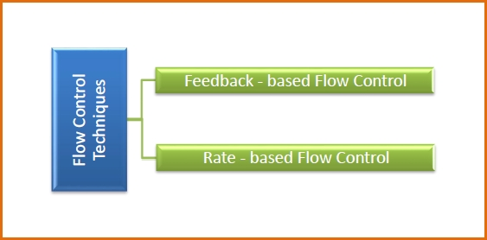
- Feedback based Flow Control In these protocols, the sender sends frames after it has received acknowledgments from the user. This is used in the data link layer.
- Rate based Flow Control These protocols have built in mechanisms to restrict the rate of transmission of data without requiring acknowledgment from the receiver. This is used in the network layer and the transport layer.

Flow Control
Flow control tells the sender how much data should be sent to the receiver so that it is not lost. This mechanism makes the sender wait for an acknowledgment before sending the next data. There are two ways to control the flow of data:
- Stop and Wait Protocol
- Sliding Window Protocol

Stop and Wait Protocol
It is the simplest flow control method. In this, the sender will send one frame at a time to the receiver. Until then, the sender will stop and wait for the acknowledgment from the receiver. When the sender gets the acknowledgment then it will send the next data packet to the receiver and wait for the acknowledgment again and this process will continue. This can be understood by the diagram below.
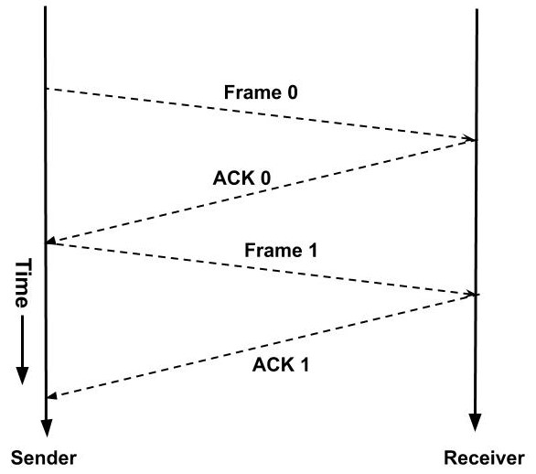
Suppose if any frame sent is not received by the receiver and is lost. So the receiver will not send any acknowledgment as it has not received any frame. Also, the sender will not send the next frame as it will wait for the acknowledgment for the previous frame which it had sent. So a deadlock situation can be created here. To avoid any such situation there is a time-out timer. The sender will wait for this fixed amount of time for the acknowledgment and if the acknowledgment is not received then it will send the frame again.
There are two types of delays while sending these frames:
- Transmission Delay: Time taken by the sender to send all the bits of the frame onto the wire is called transmission delay. This is calculated by dividing the data size(D) which has to be sent by the bandwidth(B) of the link.
Td = D / B
- Propagation Delay: Time taken by the last bit of the frame to reach from one side to the other side is called propagation delay. It is calculated by dividing the distance between the sender and receiver by the wave propagation speed.
Tp = d / s ; where d = distance between sender and receiver, s = wave propagation speed
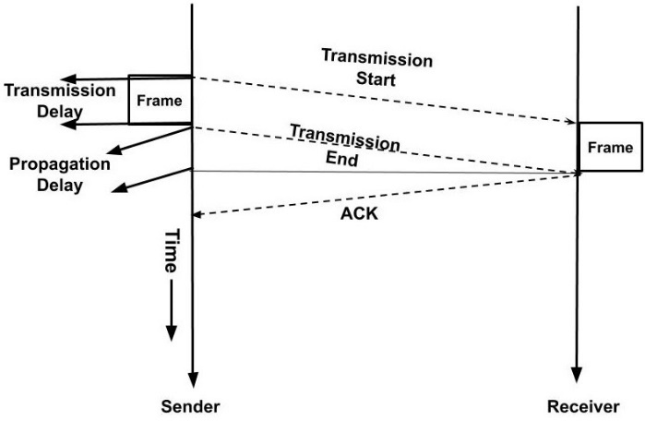
The propagation delay for sending the data frame and the acknowledgment frame is the same as distance and speed will remain the same for both frames. Hence, the total time required to send a frame is
Total time= Td(Transmission Delay) + Tp(Propagation Delay for data frame) + Tp(Propagation Delay for acknowledgment frame)
The sender is doing work only for Td time and for the rest 2Tp time the sender is waiting for the acknowledgment.
Efficiency = Useful Time/ Total Time
η=Td / (Td+2Tp)

Advantages of Stop and Wait Protocol
- It is very simple to implement.

Disadvantages of Stop and Wait Protocol
- We can send only one packet at a time.
- If the distance between the sender and the receiver is large then the propagation delay would be more than the transmission delay. Hence, efficiency would become very low.
- After every transmission, the sender has to wait for the acknowledgment and this time will increase the total transmission time.

Sliding Window Protocol
As we saw that the disadvantage of the stop and wait protocol is that the sender waits for the acknowledgment and during that time the sender is idle. In sliding window protocol we will utilize this time. We will change this waiting time into transmission time.
A window is a buffer where we store the frames. Each frame in a window is numbered. If the window size is n then the frames are numbered from the number 0 to n-1. A sender can send n frames at a time. When the receiver sends the acknowledgment of the frame then we need not store that frame in our window as it has already been received by the receiver. So, the window in the sender side slides to the next frame and this window will now contain a new frame along with all the previous unacknowledged frames of the window. At any instance of time window will only contain the unacknowledged frames. This can be understood with the example below:
- Suppose the size of the window is 4. So, the frames would be numbered as 0,1,2,3,0,1,2,3,0,… so on.
- Initially, the frames in the window are 0,1,2, 3. Now, the sender starts transmitting the frames. The first frame is sent, then second and so on.
- When the receiver receives the first frame i.e. frame 0. Then it sends an acknowledgment.
- When the acknowledgment is received by the sender then it knows that the first frame has been received by the receiver and it need not keep its record. So, the window slides to the next frame.
- The new window contains the frame 1, 2, 3, 0. In this way, the window slides hence the name sliding window protocol.
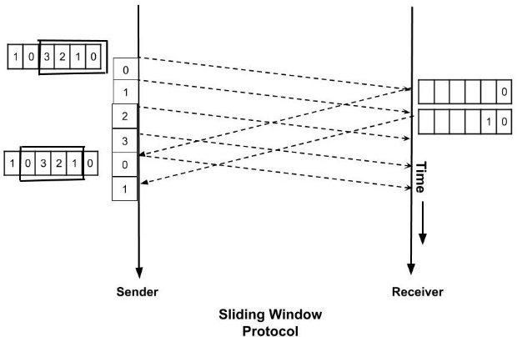
Using sliding window protocol, the efficiency can be made maximum i.e. 1. In sliding window protocol we are using the propagation delay time also for the transmission. For doing this we the sender should be sending the data frame all the time i.e for Td+2Tp time. So, what should be the number of packets such that the efficiency is maximum?
We will apply a simple unitary method to find this. In Td units of time, we can send one packet. So in one unit of time, we can send 1/Td packets. We have total time as Td+2Tp. Therefore, in Td+2Tp time we can send (Td+2Tp)/Td packets. Let a=Tp/Td. So, if we send 1+2a packets then the efficiency is 1.
Td units of time → 1 packet transmitted
1 unit of time → (1/ Td) packet transmitted
Td + 2Tp units of time → (Td + 2Tp) / Td packets transmitted
This is how the flow of data is controlled using the above two mechanisms.
There are many reasons such as noise, cross-talk etc., which may help data to get corrupted during transmission. The upper layers work on some generalized view of network architecture and are not aware of actual hardware data processing. Hence, the upper layers expect error-free transmission between the systems. Most of the applications would not function expectedly if they receive erroneous data. Applications such as voice and video may not be that affected and with some errors they may still function well.
Data-link layer uses some error control mechanism to ensure that frames (data bit streams) are transmitted with certain level of accuracy. But to understand how errors is controlled, it is essential to know what types of errors may occur.

Types of Errors
There may be three types of errors:
- Single bit error
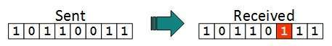
In a frame, there is only one bit, anywhere though, which is corrupt.
- Multiple bits error
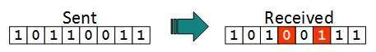
Frame is received with more than one bits in corrupted state.
- Burst error
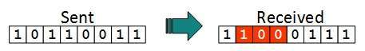
Frame contains more than1 consecutive bits corrupted.
Error control mechanism may involve two possible ways:
- Error detection
- Error correction

Error Detection
Errors in the received frames are detected by means of Parity Check and Cyclic Redundancy Check (CRC). In both cases, few extra bits are sent along with actual data to confirm that bits received at other end are same as they were sent. If the counter-check at receiver’ end fails, the bits are considered corrupted.

Parity Check
One extra bit is sent along with the original bits to make number of 1s either even in case of even parity, or odd in case of odd parity.
The sender while creating a frame counts the number of 1s in it. For example, if even parity is used and number of 1s is even then one bit with value 0 is added. This way number of 1s remains even.If the number of 1s is odd, to make it even a bit with value 1 is added.
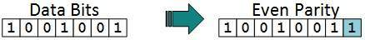
The receiver simply counts the number of 1s in a frame. If the count of 1s is even and even parity is used, the frame is considered to be not-corrupted and is accepted. If the count of 1s is odd and odd parity is used, the frame is still not corrupted.
If a single bit flips in transit, the receiver can detect it by counting the number of 1s. But when more than one bits are erro neous, then it is very hard for the receiver to detect the error.

Cyclic Redundancy Check (CRC)
CRC is a different approach to detect if the received frame contains valid data. This technique involves binary division of the data bits being sent. The divisor is generated using polynomials. The sender performs a division operation on the bits being sent and calculates the remainder. Before sending the actual bits, the sender adds the remainder at the end of the actual bits. Actual data bits plus the remainder is called a codeword. The sender transmits data bits as codewords.
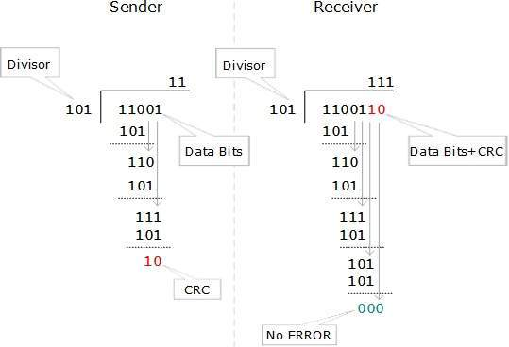
At the other end, the receiver performs division operation on codewords using the same CRC divisor. If the remainder contains all zeros the data bits are accepted, otherwise it is considered as there some data corruption occurred in transit.

Error Correction
In the digital world, error correction can be done in two ways:
- Backward Error Correction When the receiver detects an error in the data received, it requests back the sender to retransmit the data unit.
- Forward Error Correction When the receiver detects some error in the data received, it executes error-correcting code, which helps it to auto-recover and to correct some kinds of errors.
The first one, Backward Error Correction, is simple and can only be efficiently used where retransmitting is not expensive. For example, fiber optics. But in case of wireless transmission retransmitting may cost too much. In the latter case, Forward Error Correction is used.
To correct the error in data frame, the receiver must know exactly which bit in the frame is corrupted. To locate the bit in error, redundant bits are used as parity bits for error detection. For example, we take ASCII words (7 bits data), then there could be 8 kind of information we need: first seven bits to tell us which bit is error and one more bit to tell that there is no error.
For m data bits, r redundant bits are used. r bits can provide 2r combinations of information. In m+r bit codeword, there is possibility that the r bits themselves may get corrupted. So the number of r bits used must inform about m+r bit locations plus no-error information, i.e. m+r+1.

Error Detection And Correction in Computer Network
An error occurs when the output information does not match the input information. Digital signals suffer from noise during transmission, which can create errors in binary bits travelling from one system to another. That is, a 0 bit may become a 1 bit, or a 1 bit may become a 0.
Many factors, including noise and cross-talk, can contribute to data corruption during transmission. The top layers are unaware of real hardware data processing and work on a generic picture of network architecture. As a result, the top levels anticipate error-free transmission between the systems.
Most programs would not work normally if they received incorrect data. Voice and video applications, for example, may be unaffected and continue to work normally despite occasional problems.

Error Detection:
When a message is sent, it may be jumbled by noise or the data may be damaged. To avoid this, we employ error-detecting codes, which are bits of extra data appended to a digital message to assist us detect whether an error occurred during transmission.

Error Detection Techniques:

1. Simple Parity Check:
- One extra bit is transmitted in addition to the original bits to make the number of 1s even in the case of even parity or odd in the case of odd parity.
- While creating a frame, the sender counts the amount of 1s in it. If even parity is utilised and the number of 1s is even, one bit with the value 0 is added. In this manner, the number of 1s remains even. If the number of 1s is odd, a value 1 is added to make it even.
- The receiver just counts how many 1s are in a frame. If the number of 1s is even and even parity is utilised, the frame is regarded as uncorrupted and approved. Even if the number of 1s is odd and odd parity is utilised, the frame is not damaged.
- The receiver can identify a single bit flip in transit by counting the number of 1s. However, when more than one bit is incorrect, it is extremely difficult for the receiver to identify the problem.
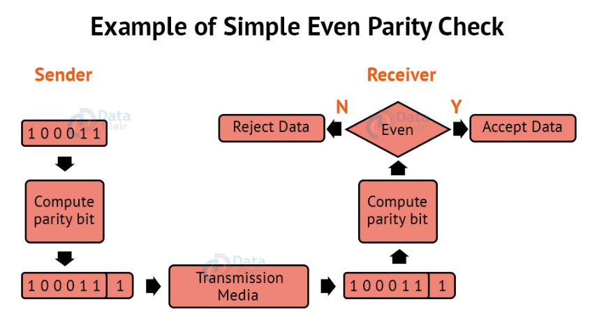

Checksum:
The data is split into k segments of m bits each in the checksum error detection technique.
To get the total, the segments are summed at the sender’s end using 1’s complement arithmetic. To obtain the checksum, a complement of the sum is taken.
The checksum segment is sent with the data segments.
To obtain the total, all received segments are summed using 1’s complement arithmetic at the receiver’s end. The sum is then calculated.
If the result is 0, the data is accepted; otherwise, it is rejected.
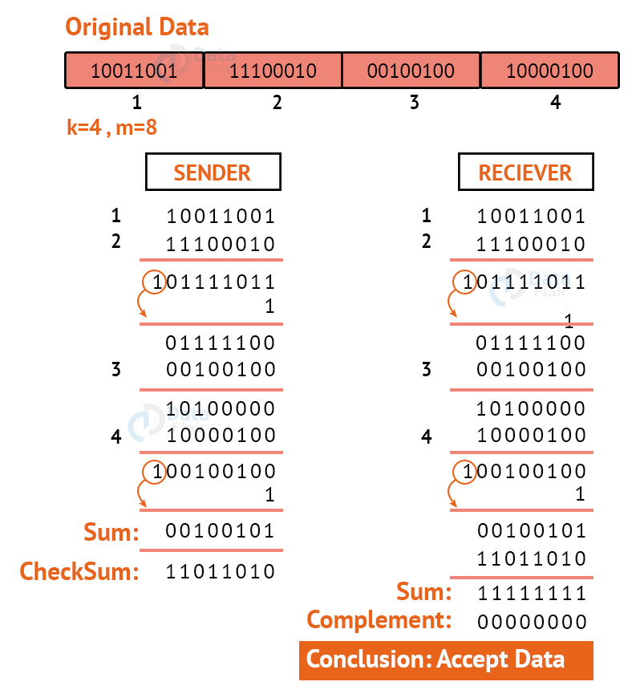

4. Cyclic Redundancy Check:
CRC is an alternative method for determining whether or not a received frame includes valid data. The binary division of the data bits being delivered is used in this approach. Polynomials are used to generate the divisor.
The sender divides the bits that are being transferred and calculates the remainder. The sender inserts the remainder at the end of the original bits before sending the actual bits. A codeword is made up of the actual data bits plus the remainder. The transmitter sends data bits in the form of codewords.
The receiver, on the other hand, divides the codewords using the same CRC divisor. If the remainder consists entirely of zeros, the data bits are validated; otherwise, it is assumed that some data corruption happened during transmission.
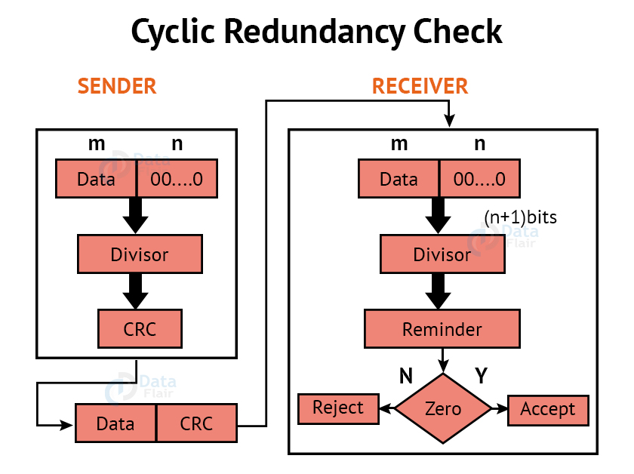

Error Correction:
Error Correction codes are used to detect and repair mistakes that occur during data transmission frobm the transmitter to the receiver.
There are two approaches to error correction:

1. Backward Error Correction:
When a backward mistake is detected, the receiver requests that the sender retransmit the complete data unit.

2. Forward Error Correction:
In this scenario, the error-correcting code is used by the receiver, which automatically corrects the mistakes.
A single extra bit can identify but not repair the mistake.
To correct the mistakes, the specific location of the error must be known. If we wish to compute a single-bit mistake, for example, the error correcting algorithm will identify which one of seven bits is incorrect. We will need to add some more redundant bits to do this.
The number of redundant bits is calculated using the following formula:
2^{r}>=d+r+1
The above formula is used to compute the value of r. For example, if the value of d is 4, the least possible number that fulfils the above relation is 3.

Error Correction Techniques:

1. Hamming Code:
Parity bits: A bit that is added to the original binary data to make sure the total number of 1s is even or odd (in case of even or odd parity respectively).
Even parity: To check for even parity, if the total number of 1s is even, the parity bit value is 0. If the total number of occurrences of 1s is odd, the parity bit value is 1.

Odd Parity: To test for odd parity, if the total number of 1s is even, the parity bit value is 1. If the total number of 1s is odd, the parity bit value is 0.

- To produce d+r, an information of ‘d’ bits is added to the redundant bits ‘r’.
- Each (d+r) digit’s position is assigned a decimal value.
- The ‘r’ bits are assigned to locations 1, 2,….2k-1.
- The parity bits are recalculated at the receiving end. The position of an error is determined by the decimal value of the parity bits.
- Example: If the data to be transmitted is 1011001
- Number of data bits = 7
- Thus, number of redundancy bits = 4
- Total bits = 7+4 = 11
- Redundant bits are always placed at positions that correspond to the power of 2, so the redundant bits will be placed at positions: 1,2,4 and 8.
Redundant bits will be placed here:
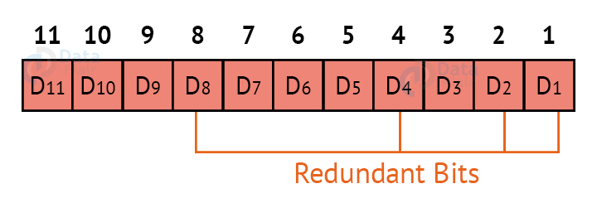
Thus now, all the 11 bits will look like this:
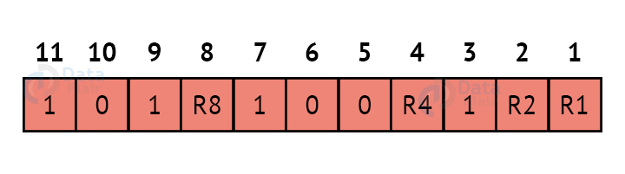
Here, R1, R2, R4 and R8 are the redundant bits.

Determining the parity bits:

R1:
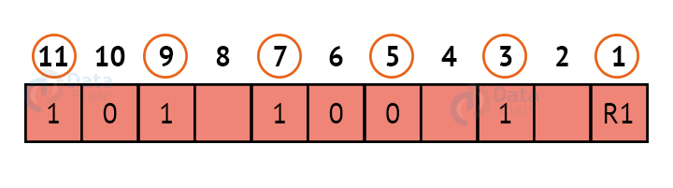
We look at bits 1,3,5,7,9,11 to calculate R1. In this case, because the number of 1s in these bits together is even, we make the R1 bit equal to 0 to maintain even parity.

R2:
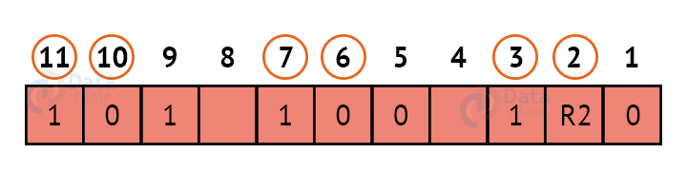
We look at bits 2,3,6,7,10,11 to calculate R2. In this case, because the number of 1s in these bits together is odd, we make the R2 bit equal to 1 to maintain even parity.

R4:
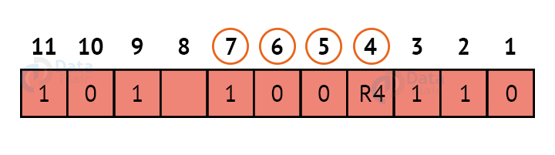
We look at bits 4,5,6,7 to calculate R4. In this case, because the number of 1s in these bits together is odd, we make the R4 bit equal to 1 to maintain even parity.

R8:
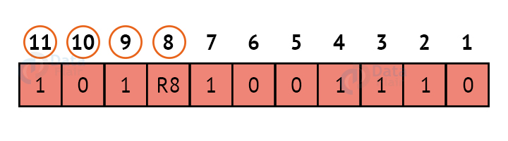
We look at bits 8,9,10,11 to calculate R8. In this case, because the number of 1s in these bits together is even, we make the R8 bit equal to 0 to maintain even parity. Thus, the final block of data which is transferred looks like this:
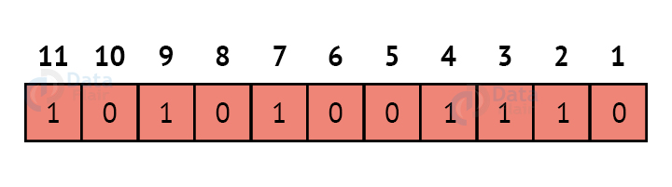

What is Ethernet : Types, Features & Its Categories
At present, computer networking has turned into an essential part for professionals, Individuals, and & academics because they rely on computer networks for different purposes like electronic mail, entrée to remote databases for investigation. Thus, networking has become increasingly pervasive because it is efficient, good connectivity, fast, effective, low cost, easy migration to high-speed networks & reliable.
For a normal computer user, it is a mystery to know how all the data is transmitted, stored, classified. It is not a single protocol however set of dissimilar standards that come from the IEEE with 802.3. So, it is the main alternative for local area networks.
If you want to know about what is Ethernet, you must be aware of advanced technologies like Arduino development board, Raspberry pi, and many more. It is a standard communication protocol embedded in software and hardware devices. It is used for building a local area network. The local area network is a computer network that interconnects a group of computers and shares information through cables or wires.

What is Ethernet?
At present, the most frequently used physical layer LAN technology is Ethernet. Ethernet meaning is a system that is used to connect a number of computers to make a LAN (local area network). This system uses protocols for controlling data transmission by avoiding immediate transmission using a number of systems. For its connection, the number of conductors is necessary to provide the data transmission framework.
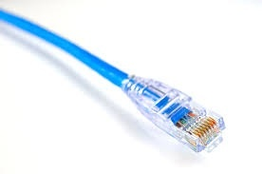
Ethernet Cable
The data transmission range of a typical type is upto 10 Mbps (Megabits for each second). Other types of LANs are Token Ring, 10 Gigabit, Gigabit, Fast, FDDI (Fiber Distributed Data Interface), LocalTalk & ATM (Asynchronous Transfer Mode). It is most popular because it hits a good balance among cost, speed & easy installation. Because of these pros, Ethernet in computer networks will give support to all popular network protocols.
At present, this has become an ideal networking technology for computer users. Ethernet can be defined as a method of connecting computers as one in a LAN (local area network). It is the most frequently used technique from the past many years for connecting computers jointly in local area networks. The basic design of this can be done by connecting many computers by allowing it and the main function of this network is to transmit the data at any time.
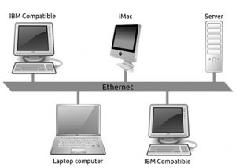
Ethernet LAN
The IEEE (Institute for Electrical and Electronics Engineers) implemented an IEEE Standard 802.3 is called an Ethernet standard. This standard describes policies for arranging a network & also states that how the elements within the network system communicate with others. By using the IEEE standard, the communication network device as well as network protocols can interact very efficiently.

Wired Ethernet Network
This technology mainly works with the fiber optic cables that connect devices within a distance of 10 km and it supports 10 Mbps.
A computer network interface card (NIC) is installed in each computer and is assigned to a unique address. An Ethernet cable runs from each NIC to the central switch or hub. The switch and hub act as a relay though they have significant differences in the manner in which they handle network traffic – receiving and directing packets of data across the LAN. Thus, this networking creates a communications system that allows the sharing of data and resources including printers, fax machines, and scanners.

Wireless Ethernet
These networks can also be wireless, rather than using Ethernet cable to connect the computers, wireless NICs use radio waves for two-way communication with a wireless switch or hub. It consists of Ethernet ports, wireless NICs, switches, and hubs. Wireless network technology can be more flexible to use but also require extra care in configuring security.

What an Ethernet Cable Looks Like?
This cable is similar to a telephone cable except for the connector because it is wider. A telephone cable includes four pins whereas an Ethernet cable includes eight pins.
For instance, if a laptop includes an Ethernet port, then the cable can be plug in to make a wired connection using a router or modem. The cable connector of this network will make a noise once the plastic spring inserted within the port of the network so that it indicates the cable is tightly plugged in toward the socket because it must have a suitable electrical connection. These cables are available in different lengths as well as colors.

Wireless Ethernet
These networks can also be wireless, rather than using Ethernet cable to connect the computers, wireless NICs use radio waves for two-way communication with a wireless switch or hub. It consists of Ethernet ports, wireless NICs, switches, and hubs. Wireless network technology can be more flexible to use but also require extra care in configuring security.

What an Ethernet Cable Looks Like?
This cable is similar to a telephone cable except for the connector because it is wider. A telephone cable includes four pins whereas an Ethernet cable includes eight pins.
For instance, if a laptop includes an Ethernet port, then the cable can be plug in to make a wired connection using a router or modem. The cable connector of this network will make a noise once the plastic spring inserted within the port of the network so that it indicates the cable is tightly plugged in toward the socket because it must have a suitable electrical connection. These cables are available in different lengths as well as colors.

Popular Standards
The popular Ethernet standards include the following.
- For 10 Mbps bandwidth, the Informal name of Ethernet is 10BASE-T, IEEE name is 802.3, and Cable Type is UTP 100m.
- For 100 Mbps bandwidth, the Fast Ethernet name is 100BASE-T, IEEE name is 802.3u and Cable Type is UTP 100m.
- For 1000 Mbps bandwidth, the Gigabit Ethernet name is 1000BASE-LX, IEEE name is 802.3z and Cable Type is Fiber 5000m
- For 1000 Mbps bandwidth, the Gigabit Ethernet name is 1000BASE-T, IEEE name is 802.3ab and Cable Type is UTP 100m
- For 10 Gbps bandwidth, the 10 Gigabit Ethernet name is 10GBASE-T, IEEE name is 802.3an and Cable Type is UTP 100m

Top 10 Best Ethernet Cables
Ethernet cables are the most frequently used network cables for wired networks. These cables are mainly used for connecting devices that are located on LANs (local area networks) like PCs, switches & routers. This is a wired network that uses cables by connecting through Ethernet ports on computers, network routers, etc.
There are different types of Ethernet cables are available in the market. The classification of these cables can be done based on the application. Here, we are listing the top 10 Ethernet cables.
- Cat5e RJ45 Booted
- Cat6 RJ45 Booted
- Cat6a SSTP LSOH Booted
- Cat5e RJ45 Shielded
- PatchSee Cat5e RJ45
- Cat5e RJ45 LSOH
- Cat6 RJ45 SFTP Shielded
- Excel Cat6A Unscreened U/UTP LSOH Booted
- Cat5e RJ45
- PatchSee Cat6 RJ45

Types of Ethernet Networks
There are several types of Ethernet networks, such as Fast, Gigabit, and Switch. A network is a group of two or more computer systems connected together.

Fast Ethernet
The fast Ethernet is a type of network that can transfer data at a rate of 100 Mbps using a twisted-pair cable or a fiber-optic cable. The older 10 Mbps Ethernet is still used, but such networks do not provide the necessary bandwidth for some network-based video applications.
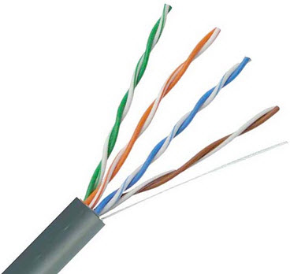
Twisted pair cable
Fast type network is based on the proven CSMA/CD Media Access Control (MAC) protocol and uses existing 10BaseT cabling. Data can move from 10 Mbps to 100 Mbps without any protocol translation or changes to the application and networking software.
What is Ethernet Port Speed?

When compared to a 10 Mb port, a 100 Mb port is theoretically 10 times faster than the standard port. Therefore, with a 100 Mb port, more information can stream to and from your server. This will be of great help to you if you really need to explore very high speed, but not if you are under DDOS attack because you will find yourself running out of traffic allocation very fast.
If you are doing standard web hosting, the bigger 100 Mbps pipe will not offer true benefit to you because you may not even use more than 1 Mbps at any given time. If you are hosting games or streaming media, then the bigger pipe of 100 Mbps would indeed be helpful to you.
With a 10 Mbps pipe, you can transfer up to 1.25 Mbps, while a 100 Mbps pipe, would allow you to transfer up to 12.5 Mbps.
However, if you leave your server unattended and running at full steam, a 10 Mbps pipe can consume about 3,240 GB a month and a 100 Mbps pipe can consume up to 32,400 GB a month. It would be really disgusting when you receive your bill.

Gigabit Ethernet
The Gigabit s a type of network capable of transferring data at a rate of 1000 Mbps based on a twisted-pair or fiber optic cable, and it is very popular. The type of twisted-pair cable that supports Gigabit Ethernet is the Cat 5e cable, where all the four pairs of twisted wires of the cable are used to achieve high data transfer rates. The 10 Gigabit Ethernet is the latest-generation, capable of transferring data at a rate of 10 Gbps using twisted-pair or fiber optic cable.
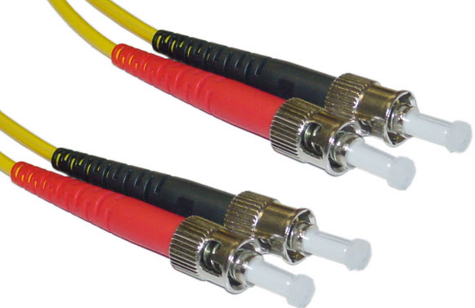
Optic fiber cable

Switch Ethernet
Multiple network devices in a LAN require network equipment such as a network switch or hub. When using a network switch, a regular network cable is used instead of a crossover cable. The crossover cable consists of a transmission pair at one end and a receiving pair at the other end.
The main function of a network switch is to forward data from one device to another device on the same network. Thus a network switch performs this task efficiently as the data is transferred from one device to another without affecting other devices on the same network.
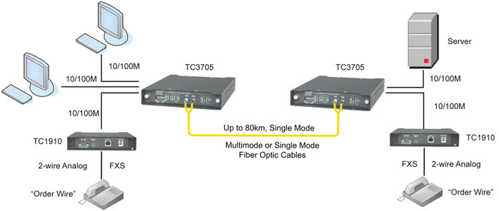Switch Ethernet
The network switch normally supports different data transfer rates. The most common data transfer rates include 10 Mbps – 100 Mbps for fast Ethernet, and 1000 Mbps – 10 Gbps for the latest Ethernet.
This type of network uses a star topology, which is organized around a switch. The switch in a network uses a filtering and switching mechanism similar to the one used by the gateways, in which these techniques have been in use for a long time.

Ethernet Port
An Ethernet port is also called a socket or a jack on a computer network device used to connect the cables. The main function of this port is to connect the hardware of a wired network within MAN (metropolitan area network), an Ethernet LAN, or WAN (wide area network).
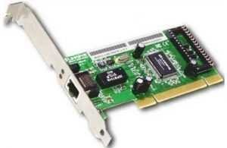
Ethernet Port
In computers or laptops, these network connections are available at the backside. A router includes numerous ports to hold several wired devices over a network. This is also applicable to other network devices such as modems and hubs.
A cable that has an RJ45 connector then it supports by an Ethernet port. So, WiFi is an alternative to use a cable through this port so that it eliminates the need for both the port as well as a cable. As compared with a phone jack, this port is wider. So it is not possible to fit this cable into a phone jack because of its shape which makes it simple once plugging in cables. The designing of Ethernet cable can be done with a clip to hold the cable within the Port.
Most of the computers comprise one inbuilt port and the main function of this port is to connect the device toward a wired network. This port can be connected to its inner network adapter known as Ethernet card, which is connected to the motherboard.

Generally, laptops include an Ethernet port, used to connect a network that doesn’t include wireless capabilities. For instance, MacBook Air doesn’t include a port however it supports an Ethernet dongle toward a USB port in the computer.
At present, these ports are available almost in networking devices. These are very powerful tools that can be used to connect several devices mutually through a cable like a router, Xbox, computer, modem, Apple TVs, PlayStation, etc.
In some devices, WiFi technology has replaced the necessity of ports however these are still used in any size of the network. But, a stable, as well as a more reliable network connection, can be obtained by connecting Ethernet ports using a cable.

Alternate Technologies
Alternative technologies of Ethernet support different types of networks or topologies such a bus topology, ring topology, star topology, tree topology, and so on. These topologies can be used for transferring and receiving data using different types of cables like coax, twisted pair, fiber optic, etc.
Alternate technologies of this network include the “Token Ring” protocol designed by IBM and the robust Asynchronous Transfer Mode (ATM) technology. ATM allows devices to be connected over very long distances to create WANs (Wide Area Networks) that behave like LANs. However, for an inexpensive network located in a single building, this network is a well-established standard with a solid record, boasting over three decades of providing reliable networking environments.
The formal designation for standardization of Ethernet protocol is referred to as IEEE 802.3. A third subcommittee works on a flavor essentially identical to Ethernet, though there are insignificant variances. Consequently, generic use of the term “Ethernet” might refer to IEEE 802.3 or DIX Ethernet.

Different Types of Cables
The different types of ethernet cables are designated according to the type and diameter of the cables used as given below:
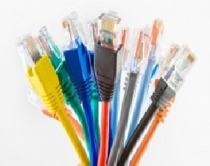
Types of Ethernet Cables
- 10Base2: The cable used is a thin coaxial cable.
- 10Base5: The cable used is a thick coaxial cable.
- 10Base-T: The cable used is a twisted-pair (T means twisted pair) and the speed achieved is around 10 Mbps.
- 100Base-FX: Makes it possible to achieve a speed of 100 Mbps by using multimode fiber optic (F stands for Fiber).
- 100Base-TX: Similar to 10Base-T, but with a speed 10 times greater (100 Mbps).
- 1000Base-T: Uses a double-twisted pair of category 5 cables and allows a speed up to one Gigabit per second.
- 1000Base-SX: Based on multimode fiber optic uses a short wavelength signal (S stands for short) of 850 nanometers (770 to 860 nm).
- 1000Base-LX: Based on multimode fiber optic uses a long-wavelength signal (L stands for long) of 1350 nm (1270 to 1355 nm). this network is a widely used network technology because the cost of such a network is not very high.

Features
The features of the ethernet controller include the following.
- Includes 1st round “hop” to a Tier 1 provider
- Provides wholesale pricing for all types of businesses
- Connects directly to the carrier’s backbone
- Offers Service Level Agreements with every connection
- Provides low-cost bandwidth
- Provides higher rates of data transfer
- Offers ‘Plug and Play’ provisioning

Ethernet Adapter
Network adapter is also known as Ethernet card or network interface card or NIC. Please refer to this link to know more about Network Interface Card.

Ethernet Switch
The Ethernet switch in the office or home works like a central station used to connect printers, computers, printers & other wired devices to each other. The internet can be accessed by connecting the switch to a modem or a router. Here, WiFi is the wireless counterpart to Ethernet.
In a wireless router, an Ethernet switch has three main functions. Although, separate Ethernet switches include a maximum of 48 ports, whereas the Ethernet switch within this router includes simply four ports.

Categories for Ethernet Cables
Different categories of Ethernet cable like UTP were mainly created for superior performance in some particular applications. Generally, the category number is high, the noise reduction will be high, attenuation will be low, and thus the bandwidth will be high.
For example, a category like CAT6 handles higher data rates on long distances as compared with a category like CAT5. New categories also added as the unique revision to attain these high data rates. Here, CAT5e is the most frequently used cable, applicable for most Gigabit Ethernet-based applications. The cables like CAT5e, CAT6, & CAT6a are available from different manufacturers in the market. Any kind of cable can be used in several applications only if it reaches the transfer speeds which are necessary for the application.
The different categories of UTP cable include the following.
- For a category like CAT5, the typical application is 10/100 Mbps Ethernet, the maximum frequency is 100 MHz and the maximum length for application is 100 meters for 100BASE-T
- For a category like CAT5e, the typical application is 10/100/Gigabit Ethernet, the maximum frequency is 100 MHz and the maximum length for application is 100 meters for 1000BASE-T
- For a category like CAT6, the typical application is Gigabit Ethernet, the maximum frequency is 250 MHz and the maximum length for application is 100 meters for 1000BASE-T
- For a category like CAT6a, the typical application is 10-Gigabit Ethernet, the maximum frequency is 500 MHz and the maximum length for application is 100 meters for 10GBASE-T

This cable performance mainly depends on the used length as well as how this cable is terminated.

Ethernet Cable Color Code
Ethernet cables are most frequently used in computer networking of commercial as well as residential applications once a wired network is desired for sharing the data by accessing the internet. These cables are used frequency cables are available in various colors which help in indicating the intended application. These cables are available in different colors like yellow, blue, grey, orange & white color. If the cable is located outside then the color will be black with waterproof, so that it survives longer within the elements.
The meaning of an Ethernet cable color mainly changes based on the application. For instance, with the DoD (Department of Defense), the government utilizes different Ethernet cords with different colors to assign a given level of arrangement for the data being transmitted in the cable. For instance, the yellow color cable is used for top-secret, the blue color is used for unclassified data and the red color is used for mid-level.
The standard colors of cables that are used through patch cord jackets by Wisconsin University mainly include the following.
- Grey color cable is used for typical connections
- The green color cable is used for crossover connections
- The yellow color cable is used for POE connections
- The orange color cable is used for analog non Ethernet connections
- The purple color cable is used for digital non Ethernet connections
- The blue color cable is used for terminal server connections
- The red color cable is used for IP cameras
- The black color cable is used as a general color
- The pink color cable is used as an extra color option
- The white color cable is used as an extra color option

TOKEN RING

IEEE 802.5: Token Ring Network
- Token Ring is formed by the nodes connected in ring format as shown in the diagram below. The principle used in the token ring network is that a token is circulating in the ring and whichever node grabs that token will have right to transmit the data.
- Whenever a station wants to transmit a frame it inverts a single bit of the 3-byte token which instantaneously changes it into a normal data packet. Because there is only one token, there can almost be one transmission at a time.
- Since the token rotates in the ring it is guaranteed that every node gets the token with in some specified time. So there is an upper bound on the time of waiting to grab the token so that starvation is avoided.
- There is also an upper limit of 250 on the number of nodes in the network.
- To distinguish the normal data packets from token (control packet) a special sequence is assigned to the token packet. When any node gets the token it first sends the data it wants to send, then recirculates the token.

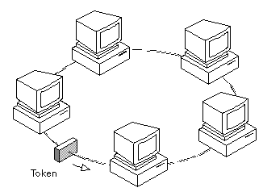
If a node transmits the token and nobody wants to send the data the token comes back to the sender. If the first bit of the token reaches the sender before the transmission of the last bit, then error situation araises. So to avoid this we should have:
propogation delay + transmission of n-bits (1-bit delay in each node ) > transmission of the token time
A station may hold the token for the token-holding time. which is 10 ms unless the installation sets a different value. If there is enough time left after the first frame has been transmitted to send more frames, then these frames may be sent as well. After all pending frames have been transmitted or the transmission frame would exceed the token-holding time, the station regenerates the 3-byte token frame and puts it back on the ring.

Modes of Operation
- Listen Mode: In this mode the node listens to the data and transmits the data to the next node. In this mode there is a one-bit delay associated with the transmission.
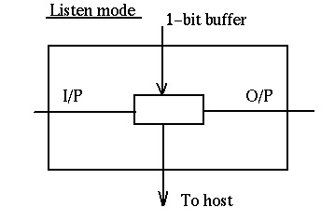

- Transmit Mode: In this mode the node just discards the any data and puts the data onto the network.
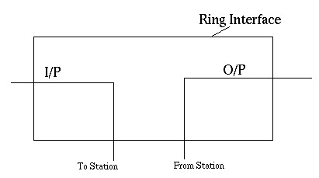

- By-pass Mode: In this mode reached when the node is down. Any data is just bypassed. There is no one-bit delay in this mode.
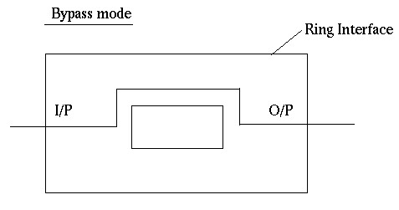

Token Ring Using Ring Concentrator

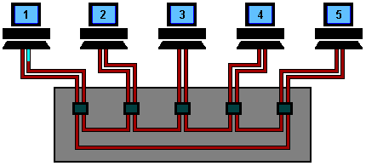
One problem with a ring network is that if the cable breaks somewhere, the ring dies. This problem is elegantly addressed by using a ring concentrator. A Token Ring concentrator simply changes the topology from a physical ring to a star wired ring. But the network still remains a ring logically. Physically, each station is connected to the ring concentrator (wire center) by a cable containing at least two twisted pairs, one for data to the station and one for data from the station. The Token still circulates around the network and is still controlled in the same manner, however, using a hub or a switch greatly improves reliability because the hub can automatically bypass any ports that are disconnected or have a cabling fault. This is done by having bypass relays inside the concentrator that are energized by current from the stations. If the ring breaks or station goes down, loss of the drive current will release the relay and bypass the station. The ring can then continue operation with the bad segment bypassed.

Who should remove the packet from the ring ?
There are 3 possibilities-
- The source itself removes the packet after one full round in the ring.
- The destination removes it after accepting it: This has two potential problems. Firstly, the solution won't work for broadcast or multicast, and secondly, there would be no way to acknowledge the sender about the receipt of the packet.
- Have a specialized node only to discard packets: This is a bad solution as the specialized node would know that the packet has been received by the destination only when it receives the packet the second time and by that time the packet may have actually made about one and half (or almost two in the worst case) rounds in the ring.
Thus the first solution is adopted with the source itself removing the packet from the ring after a full one round. With this scheme, broadcasting and multicasting can be handled as well as the destination can acknowledge the source about the receipt of the packet (or can tell the source about some error).

Token Format
The token is the shortest frame transmitted (24 bit)
MSB (Most Significant Bit) is always transmitted first - as opposed to Ethernet
SD | AC | ED
SD = Starting Delimiter (1 Octet)
AC = Access Control (1 Octet)
ED = Ending Delimiter (1 Octet)

Starting Delimiter Format:
J | K | O | J | K | O | O | O
J = Code Violation
K = Code Violation

Access Control Format:
P | P | P | T | M | R | R | R
T=Token
T = 0 for Token
T = 1 for Frame
When a station with a Frame to transmit detects a token which has a priority equal to or less than the Frame to be transmitted, it may change the token to a start-of-frame sequence and transmit the Frame
P = Priority
Priority Bits indicate tokens priority, and therefore, which stations are allowed to use it. Station can transmit if its priority as at least as high as that of the token.
M = Monitor
The monitor bit is used to prevent a token whose priority is greater than 0 or any frame from continuously circulating on the ring. If an active monitor detects a frame or a high priority token with the monitor bit equal to 1, the frame or token is aborted. This bit shall be transmitted as 0 in all frame and tokens. The active monitor inspects and modifies this bit. All other stations shall repeat this bit as received.
R = Reserved bits
The reserved bits allow station with high priority Frames to request that the next token be issued at the requested priority.

Ending Delimiter Format:

J | K | 1 | J | K | 1 | 1 | E
J = Code Violation
K = Code Violation
I = Intermediate Frame Bit
E = Error Detected Bit

Frame Format:
MSB (Most Significant Bit) is always transmitted first - as opposed to Ethernet
SD | AC | FC | DA | SA | DATA | CRC | ED | FS
SD=Starting Delimiter(1 octet)
AC=Access Control(1 octet)
FC = Frame Control (1 Octet)
DA = Destination Address (2 or 6 Octets)
SA = Source Address (2 or 6 Octets)
DATA = Information 0 or more octets up to 4027
CRC = Checksum(4 Octets)
ED = Ending Delimiter (1 Octet)
FS=Frame Status

Starting Delimiter Format:
J | K | 0 | J | K | 0 | 0 | 0
J = Code Violation
K = Code Violation

Access Control Format:

P | P | P | T | M | R | R | R
T=Token
T = “0” for Token,
T = “1” for Frame.
When a station with a Frame to transmit detects a token which has a priority equal to or less than the Frame to be transmitted, it may change the token to a start-of-frame sequence and transmit the Frame.
P = Priority
Bits Priority Bits indicate tokens priority, and therefore, which stations are allowed to use it. Station can transmit if its priority as at least as high as that of the token.
M = Monitor
The monitor bit is used to prevent a token whose priority is greater than 0 or any frame from continuously circulating on the ring. if an active monitor detects a frame or a high priority token with the monitor bit equal to 1, the frame or token is aborted. This bit shall be transmitted as 0 in all frame and tokens. The active monitor inspects and modifies this bit. All other stations shall repeat this bit as received.
R = Reserved bits the reserved bits allow station with high priority Frames to request that the next token be issued at the requested priority

Frame Control Format:

F | F | CONTROL BITS (6 BITS)
FF= Type of Packet-Regular data packet or MAC layer packet
Control Bits= Used if the packet is for MAC layer protocol itself

Source and Destination Address Format:
The addresses can be of 2 bytes (local address) or 6 bytes (global address).
local address format:
I/G (1 BIT) | NODE ADDRESS (15 BITS)
alternatively
I/G (1 BIT) | RING ADDRESS (7 BITS) | NODE ADDRESS (8 BITS)
The first bit specifies individual or group address.
universal (global) address format:
I/G (1 BIT) | L/U (1 BIT) | RING ADDRESS (14 BITS) | NODE ADDRESS (32 BITS)
The first bit specifies individual or group address.
The second bit specifies local or global (universal) address.
local group addresses (16 bits):
I/G (1 BIT) | T/B(1 BIT) | GROUP ADDRESS (14 BITS)
The first bit specifies an individual or group address.
The second bit specifies traditional or bit signature group address.
Traditional Group Address: 2Exp14 groups can be defined.
Bit Signature Group Address: 14 grtoups are defined. A host can be a member of none or any number of them. For multicasting, those group bits are set to which the packet should go. For broadcasting, all 14 bits are set. A host receives a packet only if it is a member of a group whose corresponding bit is set to 1.
universal group addresses (16 bits):
I/G (1 BIT) | RING NUMBER | T/B (1 BIT) | GROUP ADDRESS (14 BITS)
The description is similar to as above.

Data Format:
No upper limit on amount of data as such, but it is limited by the token holding time.

Checksum:
The source computes and sets this value. Destination too calculates this value. If the two are different, it indicates an error, otherwise the data may be correct.

Frame Status:
It contains the A and C bits.
A bit set to 1: destination recognized the packet.
C bit set to 1: destination accepted the packet.
This arrangement provides an automatic acknowledgement for each frame. The A and C bits are present twice in the Frame Status to increase reliability in as much as they are not covered by the checksum.

Ending Delimiter Format:
J | K | 1 | J | K | 1 | I | E
J = Code Violation
K = Code Violation
I = Intermediate Frame Bit
If this bit is set to 1, it indicates that this packet is an intermediate part of a bigger packet, the last packet would have this bit set to 0.
E = Error Detected Bit
This bit is set if any interface detects an error.
WIRELESS LAN

We are talking of Wireless LAN (WLAN) that is to say, “Wireless LAN”, not to be confused with WAN course. Also referred Radio LAN (WLAN) if the communication medium is the radio (not light infrared for example).The stations of the wireless network can communicate directly with each other, we called Ad Hoc network type, or via relay terminals called APs (Access Points, PA) then it is an infrastructure network. the second type is by far the most common in business.
The wired LAN provides reliable service to users, working in a fixed environment. Once installed, the workstations and the servers of a wired LAN are fixed in their native locations. For users who are highly mobile or in a rough terrain, where there is no possibility to install and lay down the cables of a wired LAN, a good solution is to install a wireless LAN. Wireless LANs transmit and receive data over the atmosphere, using radio frequency (RF) or infrared optical technology, there by, eliminating the need for fixed wired connections.
Wireless LANs provides dual advantage of connectivity and mobility. Wireless LANs have gained strong popularity in applications like health-care, retail, manufacturing, warehousing, and academic. These applications use hand-held terminals and notebook computers to transmit real-time information to centralized ‘hosts’ for processing. Figure shows simple wired and wireless networks.
Wireless LANs have limitations when compared with wired LANs. Wireless LANs are slower than wired LAN. Also, they have limitations with their range of operation. When a station is moved out of its range, it suffers from noise and error in the received data due to the poor signal strength.
IEEE formed a working group to develop a Medium Access Control (MAC) and Physical Layer (PHY) standard for wireless connectivity for stationary, portable, and mobile computers within a local area. This working group is IEEE 802.11. The recommendations of the 802.11 committee have become the standard for wireless networking.

Need for Wireless LANs
Networking and Internet services are essential requirements for today’s business computing. An increasing number of LAN users are becoming mobile. These mobile users require connectivity to a network, regardless of where they are because they want simultaneous access to the network. With wireless LANs, users can access shared information without looking for a place to plug in their systems and do not need network managers to set up networks to install cable and other equipment.

Advantages of Wireless LANs
Wireless LANs offer the following advantages over traditional wired networks. Mobility Users on a wireless LAN system can access to real-time information from anywhere within their organization. This mobility supports productivity and service opportunities, which are not possible with wired networks.
Fast Installation and Simplicity: Installing a wireless LAN system can be fast and easy and can eliminate the need to pull cables through walls, floor, and ceilings.
Installation Flexibility: Wireless network is suitable for any kind of geographical conditions. Installation requires to properly setup the transmitter and the receiver antenna (RF) or infrared system. This is much easier than cable installation of a wired LAN. If a company decided to move to a new location, the wireless system is much easier to move.
Reduced Cost: The initial investment required for wireless LAN hardware is higher than the cost of wired LAN hardware. However, the overall installation expenses and life cycle costs are significantly lower. Long-term cost benefits are greatest in dynamic environments, requiring frequent moves and changes.
Scalability Wireless LAN systems can be configured in a variety of topologies to cater to the need for specific applications and installations. Configurations can be easily changed. They scale well. New nodes can be added to the existing wireless LAN without much degradation of performance.

Uses of Wireless LANs
Wireless LANs frequently act as a substitute rather than replacement for a wired LAN network. They often provide the final few meters of connectivity between a wired network and the mobile user. The following list describes some of the many applications made possible through the power and flexibility of wireless LANs:
• Doctors and nurses in hospitals can be more productive because wireless hand-held terminals or notebook computers with wireless LAN capability can deliver patient information instantly.
• Consulting or accounting audit teams or small workgroups can increase the productivity with quick wireless network setup.
• Students or research scholars, attending a class inside an institute campus can instantly access the Internet to consult the catalog of the net digital library.
• Network managers in dynamic environments minimize the overhead caused by moves, extensions to networks, and other changes with wireless LANs.
• Training sites at corporations and students at universities use wireless connectivity to ease access to information, information exchanges, and learning.
• Network managers installing networked computers in older buildings find that wireless LANs are a cost-effective network infrastructure solution.
• Travelers and tourists can book their ticket through the net during their travel.
• Warehouse workers use wireless LANs to exchange information with central databases.
• Network managers implement wireless LANs to provide backup for mission-critical applications, running on wired networks.
• Senior executives in meetings make quicker decisions because they have real-time information at their fingertips.

Component of a Wireless LAN
Apart from the components needed by the conventional wired LAN, a wireless LAN needs additional components. They are the transmitters and receivers at radio frequency (RF) or infrared (IR). The RF transmitter and receivers need antennas to perform two-way communication. This area requires a wide knowledge about antenna and propagation.
Usually a trial installation is carried out before actual implementation. Hubs, bridges, network operating system, servers, and other components are functioning exactly as they were, on a wired LAN.
Mobile Clients
Mobile clients are portable computing devices that act as clients. The following are some of the mobile systems.
1. Laptop computers: Laptop PCs with two-way communication facility (Transceiver)
2. Palmtops or Personal Digital Assistants (PDA) with communication capability
3. Portable FAX
4. Cellular phones
Special Units
For network management and efficient communication, a wireless LAN needs additional equipment.
They are:
Communication units: These units perform communications within the network and also with other networks.
Security Units: These units take care of the network security.
Transceivers: A transceiver is a half-duplex device. It performs transmission and reception of data within a wireless LAN. It can be able to transmit in one direction at a time.
Portable bridges: Portable Bridge can support internet working functions. Two wireless LANs can communicate with each other using a bridge. It can be a transceiver or a satellite port or other communication unit that provides a bridge service.

Working of Wireless LANs
Wireless LANs use electromagnetic waves (radio or infrared technology) to communicate information from one point to another without relying on any physical connection. Radio waves are often referred as radio carriers because they simply perform the function of delivering energy to a remote receiver.
The data being transmitted is superimposed on the radio carrier so that it can be accurately extracted at the receiving end. This is generally referred to as modulation of the carrier by the information being transmitted. Once data is superimposed (modulated) onto the radio carrier, the radio signal occupies more than a single frequency, since the frequency or bit rate of the modulating information adds to the carrier.
Multiple radio carriers can exist in the same space at the same time without interfering with each other if the radio waves are transmitted on different radio frequencies. To extract data, a radio receiver tunes in one radio frequency while rejecting all other frequencies.
In a typical wireless LAN configuration, a transmitter/receiver (transceiver) device, called an access point, connects to the wired network from a fixed location, using standard cabling. The access point receives, buffers, and retransmits data between the wireless LAN and the wired network infrastructure.
A single access point can support a small group of users and can function within a range of less than one hundred to several hundred feet. The access point (or the antenna attached to the access point) is usually mounted high but may be mounted essentially anywhere that is practical as long as the desired radio coverage is obtained.
End users access the wireless LAN through wireless LAN adapters, which are implemented as add-on cards in notebook or palmtop computers, as cards in desktop computers, or integrated within hand-held computers. Wireless LAN adapters provide an interface between the client network operating system (NOS) and the airwaves via an antenna. The nature of the wireless connection is transparent to the NOS.

There are two types of wireless networks:
• Type networks Ad Hoc, where stations communicate directly;
• Infrastructure type networks where stations communicate through access points.
To communicate, each station must of course be equipped with an adapter WiFi and a radio antenna (often integrated into the adapter). More and more computer equipment come with a built-in WiFi adapter.
Except not the case, you must buy one and connect it to the station. The connection is very varied: there are WiFi USB adapters, PCMCIA, PCI, etc.
There are several variations of WiFi. In short, 802.11b and 802.11g are compatible them and both operate with the radio waves of a frequency of 2.4 GHz. The 802.11b reached a speed of 11 Mb / s and 802.11g rises to 54 Mb / s.
The 802.11a is not compatible with 802.11b and 802.11g, because it works with the waves a radio frequency of 5 GHz. It can reach 54 Mb / s. The 802.11n allows to achieve a real flow rate greater than 100 Mb / s. It is capable of operating at 2.4 GHz or 5 GHz and is compatible with the 802.11b / g and 802.11a. Unfortunately, Most 802.11n equipment available today use only tape 2.4 GHz (and are therefore not compatible with the 802.11a).
Today the WiFi version of the most used is far 802.11g. It should be rapidly overtaken by 802.11n.
The fact that WiFi is originally designed to perform WLAN does not prevent not also be used in other contexts. For example, a myriad of products, such as electronic organizers (PDAs) or Personal Data Assistant (PDAs), printers, computer monitors, VCRs or even Hi-Fi, are now equipped with WiFi connections allowing them to be linked together without any wire. In this case, the WLAN is used to achieve a WPAN. Conversely, many local authorities do not have access to top speed (ADSL is not available everywhere) are turning to WiFi to cover a town or towns with the same wireless network.
This can be called Wireless MAN (WMAN).
Finally, companies are deploying wireless networks, called hotspots1 that allow anyone to connect to the Internet wirelessly slightly across the US and around the world. So one sees now what might be called WWAN (Wireless Wide Area Networks) based on WiFi technology (WiFi technology itself, however, carries data over short distances).

802.11 Architecture
The 802.11architecture defines two types of services and three different types of stations

802.11 Services
The two types of services are
1. Basic services set (BSS)
2. Extended Service Set (ESS)

1. Basic Services Set (BSS)
• The basic services set contain stationary or mobile wireless stations and a central base station called access point (AP).
• The use of access point is optional.
• If the access point is not present, it is known as stand-alone network. Such a
BSS cannot send data to other BSSs. This type of architecture is known as adhoc architecture.
The BSS in which an access point is present is known as an infrastructure network.
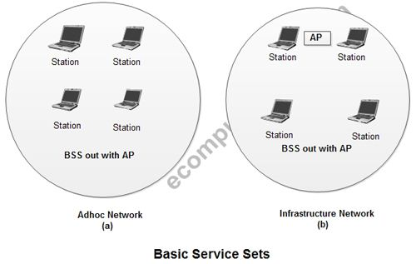

2. Extend Service Set (ESS)
• An extended service set is created by joining two or more basic service sets (BSS) having access points (APs).
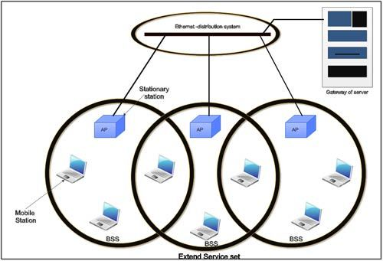
• These extended networks are created by joining the access points of basic services sets through a wired LAN known as distribution system.
• The distribution system can be any IEET LAN.
There are two types of stations in ESS:
(i) Mobile stations: These are normal stations inside a BSS.
(ii) Stationary stations: These are AP stations that are part of a wired LAN.
• Communication between two stations in two different BSS usually occurs via two APs.
• A mobile station can belong to more than one BSS at the same time.

802.11 Station Types
IEEE 802.11 defines three types of stations on the basis of their mobility in wireless LAN. These are:
1. No-transition Mobility
2. BSS-transition Mobility
3. ESS-transition Mobility
1. No-transition .Mobility: These types of stations are either stationary i.e. immovable or move only inside a BSS.
2. BSS-transition mobility: These types of stations can move from one BSS to another but the movement is limited inside an ESS.
3. ESS-transition mobility: These types of stations can move from one ESS to another. The communication mayor may not be continuous when a station moves from one ESS to another ESS.

Physical layer functions
• As we know that physical layer is responsible for converting data stream into signals, the bits of 802.11 networks can be converted to radio waves or infrared waves.
• These are six different specifications of IEEE 802.11. These implementations, except the first one, operate in industrial, scientific and medical (ISM) band. These three banks are unlicensed and their ranges are
1.902-928 MHz
2.2.400-4.835 GHz
3.5.725-5.850
GHz 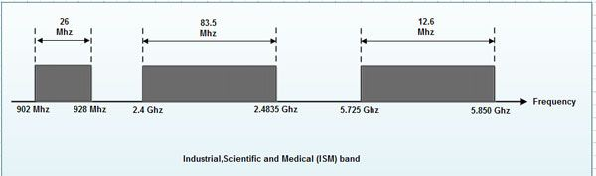
The different implementations of IEE802.11 are given below:

1. IEEE 802.11 infrared
• It uses diffused (not line of sight) infrared light in the range of 800 to 950 nm.
• It allows two different speeds: I Mbps and 2Mbps.
• For a I-Mbps data rate, 4 bits of data are encoded into 16 bit code. This 16 bit code contains fifteen as and a single 1.
• For a 2-Mbps data rate, a 2 bit code is encoded into 4 bit code. This 4 bit code contains three Os and a single 1.
• The modulation technique used is pulse position modulation (PPM) i.e. for converting digital signal to analog.

2. IEEE 802.11 FHSS
• IEEE 802.11 uses Frequency Hoping Spread Spectrum (FHSS) method for signal generation.
• This method uses 2.4 GHz ISM band. This band is divided into 79 subbands of 1MHz with some guard bands.
• In this method, at one moment data is sent by using one carrier frequency and then by some other carrier frequency at next moment. After this, an idle time is there in communication. This cycle is repeated after regular intervals.
• A pseudo random number generator selects the hopping sequence.
• The allowed data rates are 1 or 2 Mbps.
• This method uses frequency shift keying (two level or four level) for modulation i.e. for converting digital signal to analogy.

3. IEEE 802.11 DSSS
• This method uses Direct Sequence Spread Spectrum (DSSS) method for signal generation. Each bit is transmitted as 11 chips using a Barker sequence.
• DSSS uses the 2.4-GHz ISM band.
• It also allows the data rates of 1 or 2 Mbps.
• It uses phase shift keying (PSK) technique at 1 M baud for converting digital signal to analog signal.

4. IEEE 802.11a OFDM
• This method uses Orthogonal Frequency Division Multiplexing (OFDM) for signal generation.
• This method is capable of delivering data upto 18 or 54 Mbps.
• In OFDM all the subbands are used by one source at a given time.
• It uses 5 GHz ISM band.
• This band is divided into 52 subbands, with 48 subbands for data and 4 subbands for control information.
• If phase shift keying (PSK) is used for modulation then data rate is 18 Mbps. If quadrature amplitude modulation (QAM) is used, the data rate can be 54 Mbps.

5. IEEE 802.11b HR-OSSS
• It uses High Rate Direct Sequence Spread Spectrum method for signal generation.
• HR-DSSS is similar to DSSS except for encoding method.
• Here, 4 or 8 bits are encoded into a special symbol called complementary code key (CCK).
• It uses 2.4 GHz ISM band.
• It supports four data rates: 1,2,5.5 and 11 Mbps.
• 1 Mbps and 2 Mbps data rates uses phase shift modulation.
• The 5.5. Mbps version uses BPSK and transmits at 1.375 Mbaud/s with 4-bit CCK encoding.
• The 11 Mbps version uses QPSK and transmits at 1.375 Mbps with 8-bit CCK encoding.

6. IEEE 802.11g OFDM
• It uses OFDM modulation technique.
• It uses 2.4 GHz ISM band.
• It supports the data rates of 22 or 54 Mbps.
• It is backward compatible with 802.11 b.

MAC sublayer Functions
802.11 support two different modes of operations. These are:
1. Distributed Coordination Function (DCF)
2. Point Coordination Function (PCF)

1. Distributed Coordination Function
• The DCF is used in BSS having no access point.
• DCF uses CSMA/CA protocol for transmission.
• The following steps are followed in this method.
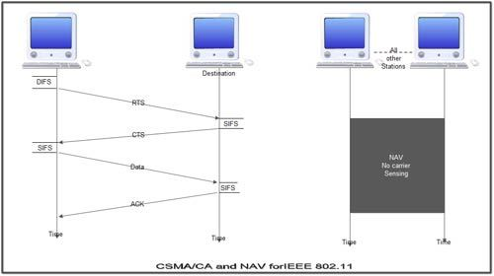
1. When a station wants to transmit, it senses the channel to see whether it is free or not.
2. If the channel is not free the station waits for back off time.
3. If the station finds a channel to be idle, the station waits for a period of time called distributed interframe space (DIFS).
4. The station then sends control frame called request to send (RTS) as shown in figure.
5. The destination station receives the frame and waits for a short period of time called short interframe space (SIFS).
6. The destination station then sends a control frame called clear to send (CTS) to the source station. This frame indicates that the destination station is ready to receive data.
7. The sender then waits for SIFS time and sends data.
8. The destination waits for SIFS time and sends acknowledgement for the received frame.

Collision avoidance
802.11 standard uses Network Allocation Vector (NAV) for collision avoidance.
• The procedure used in NAV is explained below:
1. Whenever a station sends an RTS frame, it includes the duration of time for which the station will occupy the channel.
2. All other stations that are affected by the transmission creates a timer caned network allocation vector (NAV).
3. This NAV (created by other stations) specifies for how much time these stations must not check the channel.
4. Each station before sensing the channel, check its NAV to see if has expired or not.
5. If its NA V has expired, the station can send data, otherwise it has to wait.

There can also be a collision during handshaking i.e. when RTS or CTS control frames are exchanged between the sender and receiver. In this case following procedure is used for collision avoidance:
1. When two or more stations send RTS to a station at same time, their control frames collide.
2. If CTS frame is not received by the sender, it assumes that there has been a collision.
3. In such a case sender, waits for back off time and retransmits RTS.

2. Point Coordination Function
• PCF method is used in infrastructure network. In this Access point is used to control the network activity.
• It is implemented on top of the DCF and IS used for time sensitive transmissions.
• PCF uses centralized, contention free polling access method.
• The AP performs polling for stations that wants to transmit data. The various stations are polled one after the other.
• To give priority to PCF over DCF, another interframe space called PIFS is defined. PIFS (PCF IFS) is shorter than DIFS.
• If at the same time, a station is using DCF and AP is using PCF, then AP is given priority over the station.
• Due to this priority of PCF over DCF, stations that only use DCF may not gain access to the channel.
• To overcome this problem, a repetition interval is defined that is repeated continuously. This repetition interval starts with a special control frame called beacon frame.
• When a station hears beacon frame, it start their NAV for the duration of the period of the repetition interval.

Frame Format of 802.11
The MAC layer frame consists of nine fields.
1. Frame Control (FC). This is 2 byte field and defines the type of frame and some control information. This field contains several different subfields.
These are listed in the table below:
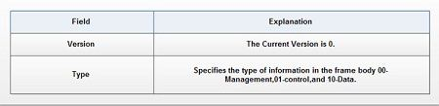
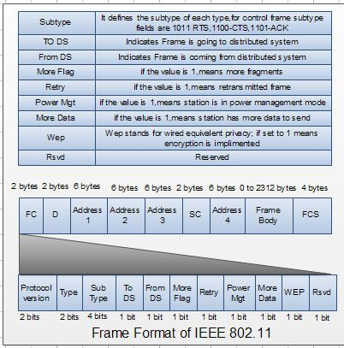
2. D. It stands for duration and is of 2 bytes. This field defines the duration for which the frame and its acknowledgement will occupy the channel. It is also used to set the value of NA V for other stations.
3. Addresses. There are 4 address fields of 6 bytes length. These four addresses represent source, destination, source base station and destination base station.
4. Sequence Control (SC). This 2 byte field defines the sequence number of frame to be used in flow control.
5. Frame body. This field can be between 0 and 2312 bytes. It contains the information.
6. FCS. This field is 4 bytes long and contains ‘cRC-32 error detection sequence.
IEEE 802.11 Frame types
There are three different types of frames:
1. Management frame
2. Control frame
3. Data frame
1. Management frame. These are used for initial communication between stations and access points.
2. Control frame. These are used for accessing the channel and acknowledging frames. The control frames are RTS and CTS.
3. Data frame. These are used for carrying data and control information.

802.11 Addressing
• There are four different addressing cases depending upon the value of To DS And from DS subfields of FC field.
• Each flag can be 0 or 1, resulting in 4 different situations.
1. If To DS = 0 and From DS = 0, it indicates that frame is not going to distribution system and is not coming from a distribution system. The frame is going from one station in a BSS to another.
2. If To DS = 0 and From DS = 1, it indicates that the frame is coming from a distribution system. The frame is coming from an AP and is going to a station. The address 3 contains original sender of the frame (in another BSS).
3. If To DS = 1 and From DS = 0, it indicates that the frame is going to a distribution system. The frame is going from a station to an AP. The address 3 field contains the final destination of the frame.
4. If To DS = 1 and From DS = 1,it indicates that frame is going from one AP to another AP in a wireless distributed system.
The table below specifies the addresses of all four cases.
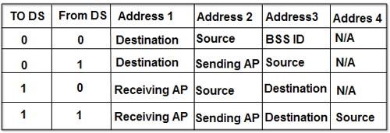
Protocols for Wireless LAN
The CSMA protocol is very difficult to implement for wireless LAN. Hence special protocols are needed to avoid collision. MACA and MACAW are the two widely used protocols.

MACA Protocol
During 1990, Kam developed the MACA (Multiple Access with Collision Avoidance) protocol for wireless transmission. The protocol is very simple to implement and works in the following manner. Station X, willing to transmit data to the nearby station Y, sends a short frame called RTS (Request to Send) first.
On hearing this short frame, all stations other than the receiving station, avoid transmission, thereby allowing the communication to take place without interference. The receiving station sends a CTS (Clear to Send) frame to the calling station.
After receiving the CTS frame, station X begins transmission. When simultaneous transmission of RTS by two stations Wand X to station Y occurs, both frames collide with each other and are lost. When there is no CTS from station Y, both stations wait for a random amount of time (binary exponential back off) and start the whole process again.

MACAW Protocol
Bhargavan et al (1994) investigated the behavior of MACA protocol and refined it with modifications. The first modification was the acknowledgment frame for the successful receipt of each frame. This modification adds carrier sense to stations.
The second modification was to apply the binary exponential back off algorithm to source-destination pair. This improves the fairness of the protocol. They have also added to stations, the ability to exchange information, regarding congestion.

